**Project Report Format**

# **Grain Palette: A Deep Learning Odyssey in Rice Type Classification**

This structured format aligns with the typical software development lifecycle and academic standards. Each section below includes a suggested structure and content guidance.

## **1. Title Page**

* **Project Title:** Grain Palette: A Deep Learning Odyssey in Rice Type Classification
* **Team Members:** Savaram Rishitha ,223N1A0555
* **Institution Name  
  Pvkk Institute of Technology**
* **Date of Submission  
  25/06/2025**

## **2. Abstract**

* A brief overview of the project (150–250 words)
* Highlight the problem statement, proposed solution, methodology (Deep Learning), and key results

## **3. Table of Contents**

* Auto-generated based on document structure
* Include page numbers for each section

**4. Ideation Phase**

* **Background:** What inspired the project?
* **Problem Identification:** Challenges in rice type classification
* **Motivation:** Importance in agriculture, trade, and quality control
* **Goals & Objectives:** What the system aims to achieve

## **5. Requirement Analysis**

* **Functional Requirements:**
  + Upload rice grain images
  + Classify into specific types (e.g., Basmati, Jasmine, etc.)
  + Display confidence score
* **Non-Functional Requirements:**
  + Accuracy threshold
  + Response time
  + Scalability
* **Hardware & Software Requirements:**
  + Deep Learning framework (e.g., TensorFlow/PyTorch)
  + Dataset source (Kaggle, custom, etc.)
  + GPU for training
  + Programming tools (Python, Jupyter, etc.)

## 

## **6. Project Design**

* **System Architecture:** (Include a diagram)
* **Data Pipeline:**
  + Image preprocessing
  + Augmentation
  + Normalization
* **Model Architecture:**
  + CNN-based model (ResNet, VGG, Custom CNN)
  + Justification for choice
* **Flowchart/Block Diagram** of the entire system

## **7. Project Planning & Scheduling**

* **Timeline:** (Include Gantt Chart if possible)
* **Phases:**
  + Data collection
  + Model building
  + Training and testing
  + Deployment
* **Milestones & Deliverables**

## 

## 

## 

## **8. Functional and Performance Testing**

* **Testing Strategy:**
  + Train/test/validation split
  + Use of cross-validation
* **Performance Metrics:**
  + Accuracy, Precision, Recall, F1-score
  + Confusion matrix
* **Results:**
  + Graphs/plots showing training/validation loss and accuracy
  + Classification report

## **9. Advantages & Disadvantages**

* **Advantages:**
  + Automates manual classification
  + Scalable to other grains
  + Fast and accurate
* **Disadvantages:**
  + Needs quality dataset
  + Performance varies with lighting/background
  + Limited to trained classes

## 

## **10. Conclusion**

* Summarize the outcome
* Was the objective met?
* Challenges overcome during development
* Key findings

## **11. Future Scope**

* Expand to more rice/grain types
* Improve model with larger datasets
* Mobile/web-based application
* Use of ensemble or hybrid models for better accuracy

## **12. Appendix**

* Output :

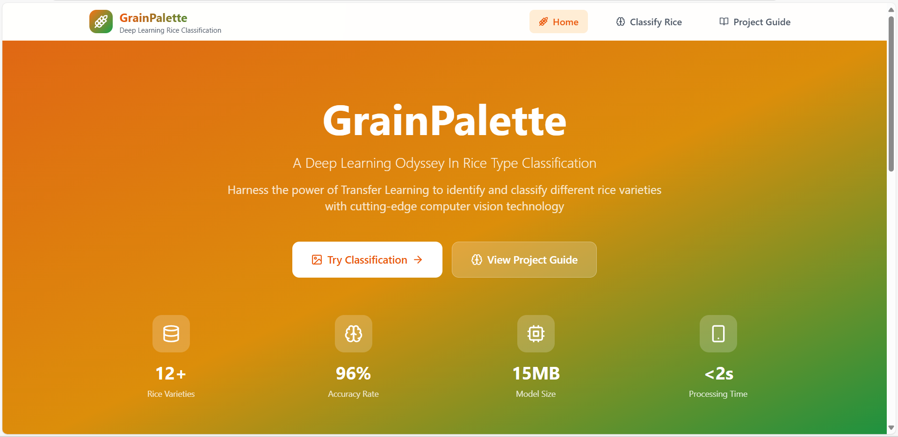

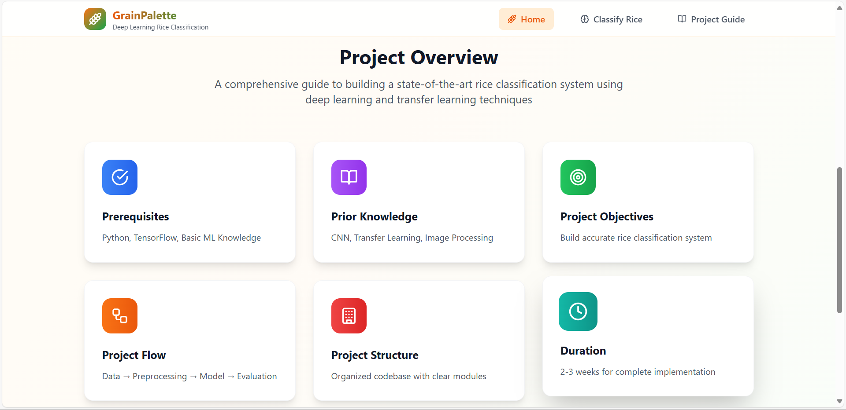

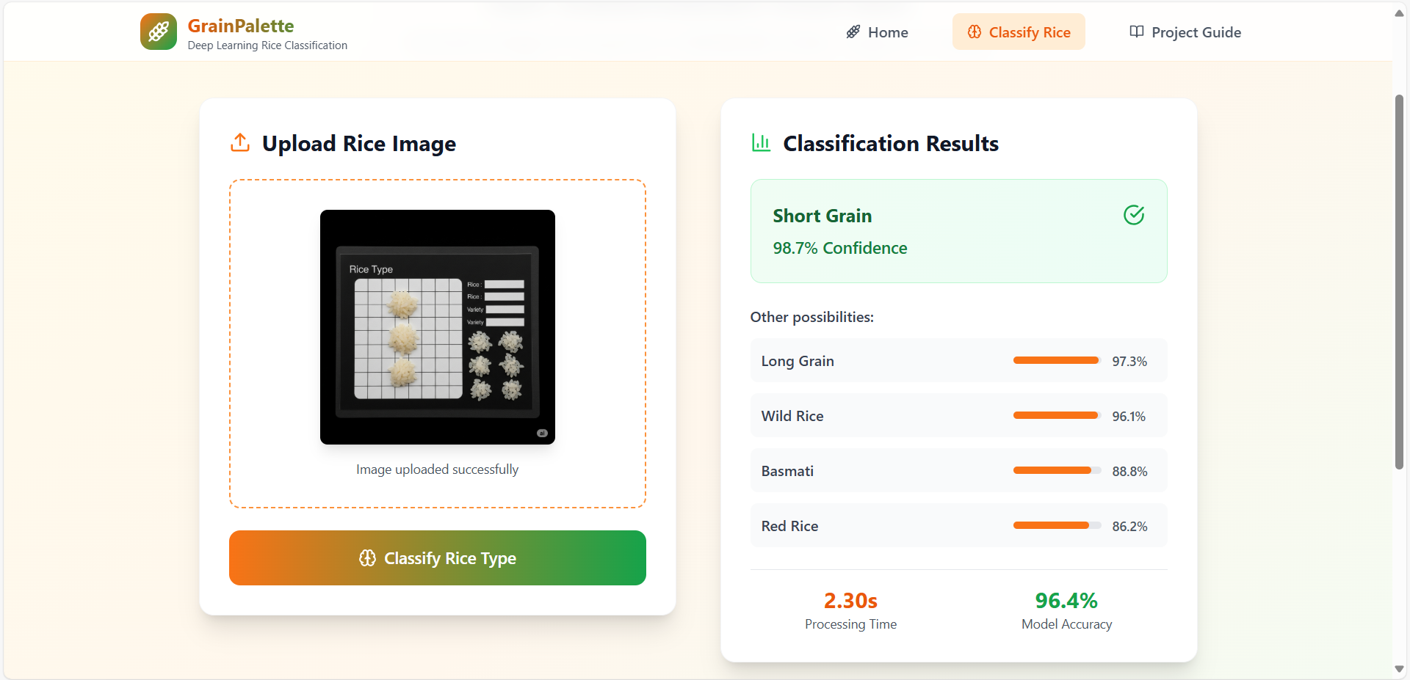

* GitHub link :